ITX-B75R1 VER:1.0
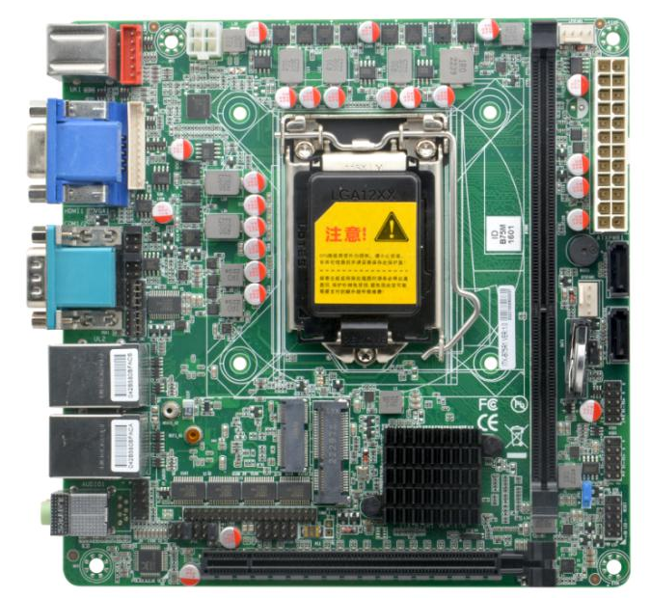
ITX-B75R1 VER:1.0 Front view
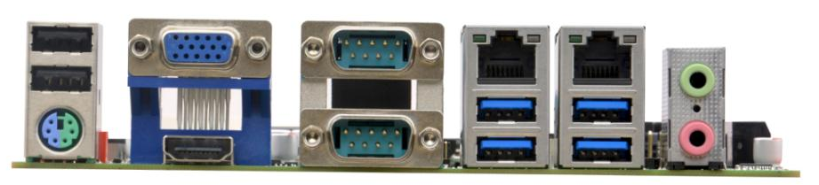
ITX-B75R1 VER:1.0 IO
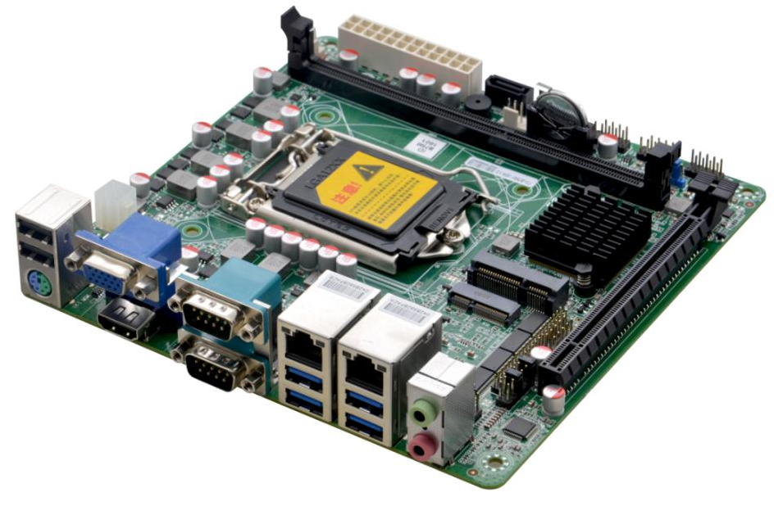
ITX-B75R1 VER:1.0 Side View

Model | ITX-B75R1 VER:1.0
Processor | Support LGA1155 architecture 2th/3th Intel Celeron/Pentium/Core i3/i5/i7 CPU
Chipset | Intel Z77/B75 Express Chipset
Memory | 1*DDR3 DIMM memory slot, support 1066/1333/1600MHz, max support 8GB
Display | Integrated Intel® HD Graphics graphics controller
Display | 1*VGA interface, 1*HDMI1.4 interface
Display | Support independent display, dual display mode and extended mode
Network | 2* RTL8111H Gigabit network card, support network wake-up, PXE function
Storage | 2*SATA2.0 hard disk interface, SATA interface transmission speed can reach 3Gbps  1*MSATA solid state hard disk interface, transmission speed can reach 6Gbps
Audio | Integrated ALC888S high-fidelity audio controller, supports Mic, Line out
Expansion | 1*PCIE2.0 x16
 | 1* M.2 slot, supports M.2 Key E WIFI module
Backplane I/O | 1*PS/2 keyboard and mouse interface
Backplane I/O | 1*VGA display interface
Backplane I/O | 1*HDMI display interface
Backplane I/O | 2*RS232 serial ports, COM1/2 supports 5V/12V power function, COM1/2 supports RS485/422 function
Backplane I/O | 2*USB 2.0 interface
Backplane I/O | 4*USB 3.0 ports
Backplane I/O | 2*RJ-45 Gigabit network interface
Backplane I/O | 1*Line out interface (green), 1*Mic interface (red)
Built-in I/O | 1*JVGA interface, 1*12pin pin header, same signal as external VGA
Built-in I/O | 1*PS/2 keyboard and mouse interface 1*6pin pin header
Built-in I/O | 1*Front audio interface 2*5pin pin header
Built-in I/O | 4*USB 2.0 interface 2*5pin pin header
Built-in I/O | 4*RS232 serial port 2*20pin pin header
Built-in I/O | 1*Front panel function button and indicator light interface 2*5pin pin header
Built-in I/O | 1*24pin ATX power input interface
Built-in I/O | 1*4pin ATX power input interface
Fan connector | 1*4pin CPU smart fan interface, 1*4pin system smart fan interface
GPIO | Support 4-way input and output GPIO function
BIOS | 32Mb Flash ROM
Watchdog | Support hardware reset function (256 levels, 0~255 seconds)
OS | Windows 7 / Linux
Power Type | 24Pin ATX power supply
Operating Temperature | -10℃～60℃
Storage Temperature | -20℃～70℃
Operating Humidity | 5～90% relative humidity, no condensation
Size | 170mm x170mm（ITX）

Ordering Information：
No. | Model | Processor | Southbridge | Memory | VGA | HDMI | LAN | USB | COM | RS485/422 | Power
1 | ITX-B75R1 VER:1.0 | LGA1155 | B75 | 1*DDR3 | 1 | 1 | 2*RTL8111H | 10 | 6 | COM1/COM2 | ATX

